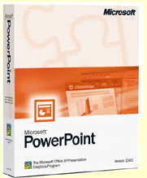
http://www.formationgratuite.com/comment-utiliser-apprendre/Microsoft-Powerpoint/microsoft-powerpoint.html

